

**Orient HBU-60CAO3T3**

**Rs. 269,000/-**

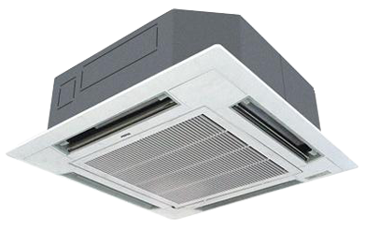

**Product Features**

* Rounding Natural Air
* Built In High Head Drain Pump
* Branch Outlet - to use 1 or 2 branches for better air distribution
* wide voltage - 175V-242V
* 50% Power saving

**Specification**

**Type** Ceiling Cassette AC

**Cooling (Btu/h)** 37000

**Voltage (V)** 220-240

**Power Input (W)** 2900

**EER (Btu/W-h-W/W)** 5.4-3.6